MINI PROJECT-II

(2020-2021)

**On**

**“Live Search Weather App”**

**FINAL REPORT**



**Institute of Engineering & Technology**

**Submitted by:-**

Ashish Agarwal (181500137-C)

Mohan Agrawal (181500385-I)

**Supervised By:-**

Mr. Akash Kumar Choudhary

**Technical Trainer**

**Department of Computer Engineering & Applications**

**DECLARATION**

We hereby declare that the work which is being presented in the B.Tech Mini Project-II **“Live Search Weather App”**, in partial fulfillment of the requirements for the award of the ***Bachelor of Technology*** in Computer Science and Engineering and submitted to the **Department of Computer Engineering and Applications, GLA University, Mathura** is an authentic record of our own work carried under the supervision of **Mr. Akash Kumar Choudhary (Technical Trainer).**

The content of this project report, either in part or in full, has not been submitted to any other Institute or University for the award of any degree.

**Team Members:**

Ashish Agarwal (181500137)

Mohan Agrawal (181500385)

Department Of Computer Engineering & Applications i

**CERTIFICATE**

This is to certify that the above statements made by the candidates are correct to the best of my/our knowledge and belief.

Signature: Mr. Akash Kumar Choudhary (Mentor)

Department Of Computer Engineering & Applications ii

**ACKNOWLEDGEMENT**

We would like to express our grateful thanks to the people who have helped us throughout the project. We are grateful to our instructor **Mr. Akash Kumar Choudhary** for nonstop support for the project. A special thanks of gratitude goes to our colleagues who helped us out in completing the project, where they all exchanged their own interesting ideas, thoughts and made possible to complete the project with accurate information. We wish to thank our college teachers for their personal support who inspired us to go own way.

Finally, we also wish to express sincere thanks to the GLA UNIVERSITY for helping us to develop this project.

Department Of Computer Engineering & Applications iii

**Contents**

|  |  |
| --- | --- |
| **Declaration** | i |
| **Certificate** | ii |
| **Acknowledgement** | iii |
| **1. Introduction** | 1 |
| 1.1 General Introduction to topic | 1 |
| 1.2 Hardware & Software Requirement | 2 |
| **2. Problem definition** | 3 |
| **3. Objective** | 4 |
| **4. Software Design**  **5. Implementation Details**  **6. Screenshots**  **7. Conclusion**  **8. References** | 5  6  8  18  19 |
|  |  |
|  |  |

**Introduction**

**1.1 General Introduction to topic**

There are many definitions for weather apps until now but still there is no consensus on one common definition. The weather app information is widely used with different meanings and purposes. In our work, we develop the React Weather app which can provide accurate forecasts to enable users to make informed decisions.

There are many benefits to different people. Since ages, humans want to know about weather conditions in advance and weather apps make it possible to predict weather conditions on the move.

In the project we are going to create live search weather app using React JS. In the project we are using React functional component, React Hooks, React Fetch API, and many more concepts in our live search weather app using React JS. In our live search weather app, the user can know about the weather conditions by entering the city, where the user wants to know about the weather.

Before installing React, we need to install node Js and npm. Also we need to install Visual Studio Code as IDE. After that we install react from the terminal. We can create react app either by using npx or npm.

Using npm we can create react app by using the command given below-:

npm install –g create-react-app

Also, we can check whether the react app is installed or not by using the command given below-:

create-react-app –version

and our react application is successfully installed.

Department Of Computer Engineering & Applications 1

**1.2 Hardware & Software requirements**

* **Hardware requirements:**

1. Processor: i3or above
2. RAM: 4 GB or above
3. Disc space: 20 GB (3 GB for database files + enough GB for shared documents, individual)
4. Network card required

* **Software requirements:**

1. Visual Studio Code as IDE
2. Git Repository
3. Operating System: Windows 7

* **Technologies Used :**

1. HTML
2. CSS
3. JAVASCRIPT
4. React JS

Department Of Computer Engineering & Applications 2

**Problem Definition**

In this project, we are going to make the live search weather app using React JS. We will also use HTML, CSS, JavaScript in our project. We will use React Functional Component, React Hooks, React Fetch API and many more concepts in our live search weather app. In our live search weather app, the user can know about the weather conditions by entering the city, where the user wants to know about the weather.

The aim of this project is to provide accurate forecasts to enable users to make informed decisions.

Since ages, humans want to know about weather conditions in advance and weather apps make it possible to predict weather conditions on the move.

Department Of Computer Engineering & Applications 3

**Objective**

The problem discussed above is only reason to developing this kind of application. **“Live Search Weather App”** gives better user experience for knowing the weather conditions across different cities.

1. Easy to use and portable.
2. The user can easily enter the city name if it exists, then it shows the current temperature in that city in degree Celsius and also if it does not exists, then it shows No Data Found.
3. The user would be able to get the minimum and maximum temperature in the city.

Department Of Computer Engineering & Applications 4

**Software Design**

1. **Activity Diagram:**

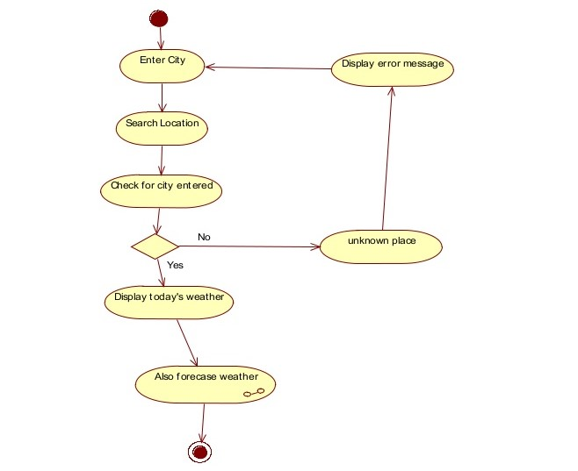

Department Of Computer Engineering & Applications 5

**Implementation Details**

**Step 1-:** Firstly, we install our react application by using npx tool or npm tool.

**Step 2-:** After installing react application, we run the command given below -:

npm start ,

which starts the development server and our react-scripts start.

**Step 3-:** When we create react app, it automatically gets created lots of files and folders.

The React Folder structure looks like-:

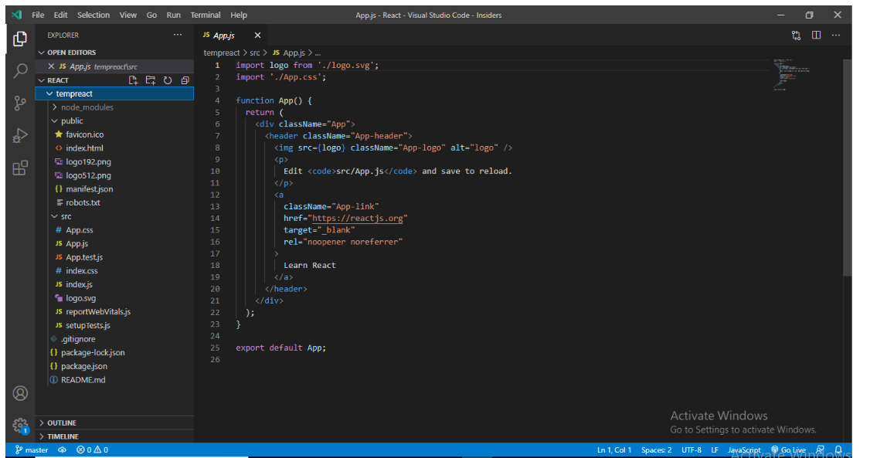

Department Of Computer Engineering & Applications 6

We Create a React app named “tempreact”.

Basically, the react folder structure contains three folders-:

1.node_modules

2.public

3.src

Package.json is a standard file found in every project. It contains the information like the name of project, versions, dependencies etc.

At the time of working with React application, for the project to build, these files must exist with exact filenames.

1. **public/index.html** is the page template.
2. **src/index.js** is the JavaScript entry point.

**Step4-:** Inside the src folder, we have created the folder named “components” and inside this folder we have created the file named “Tempapp.js”. Inside the Tempapp.js file we create a functional component called Tempapp and inside that we created React Hooks which are used to make the functional component stateful. We used useState react hook that allows you to have state variables in functional components and useEffect react hook. In our project, we called the useEffect react hook.

**Step5-:** We created the css folder and inside it we created style.css file and imported the file into the Tempapp.js file.

**Step6-:**  In the App.js file we called the Tempapp component.

**Step7-:** In the Tempapp.js file we used react event handlers like onChange().

**Step8-:** In the project we fetch the weather api through React and called the api in the code.

Department Of Computer Engineering & Applications 7

**Screenshots**

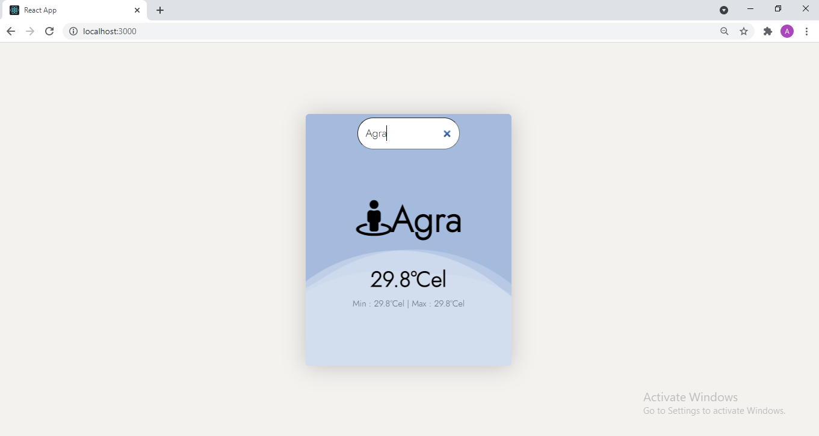

**This is the output of our running react app.**

Department Of Computer Engineering & Applications 8

**Whenever we enter the city which does not exists the output looks like this -:**

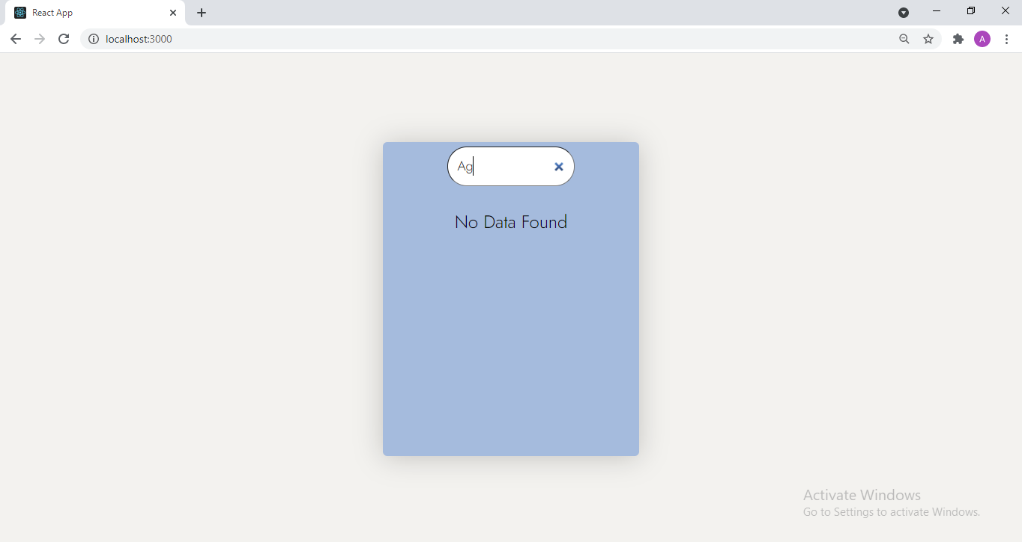

**We get the output “No Data Found” when we enter the city which does not exist.**

Department Of Computer Engineering & Applications 9

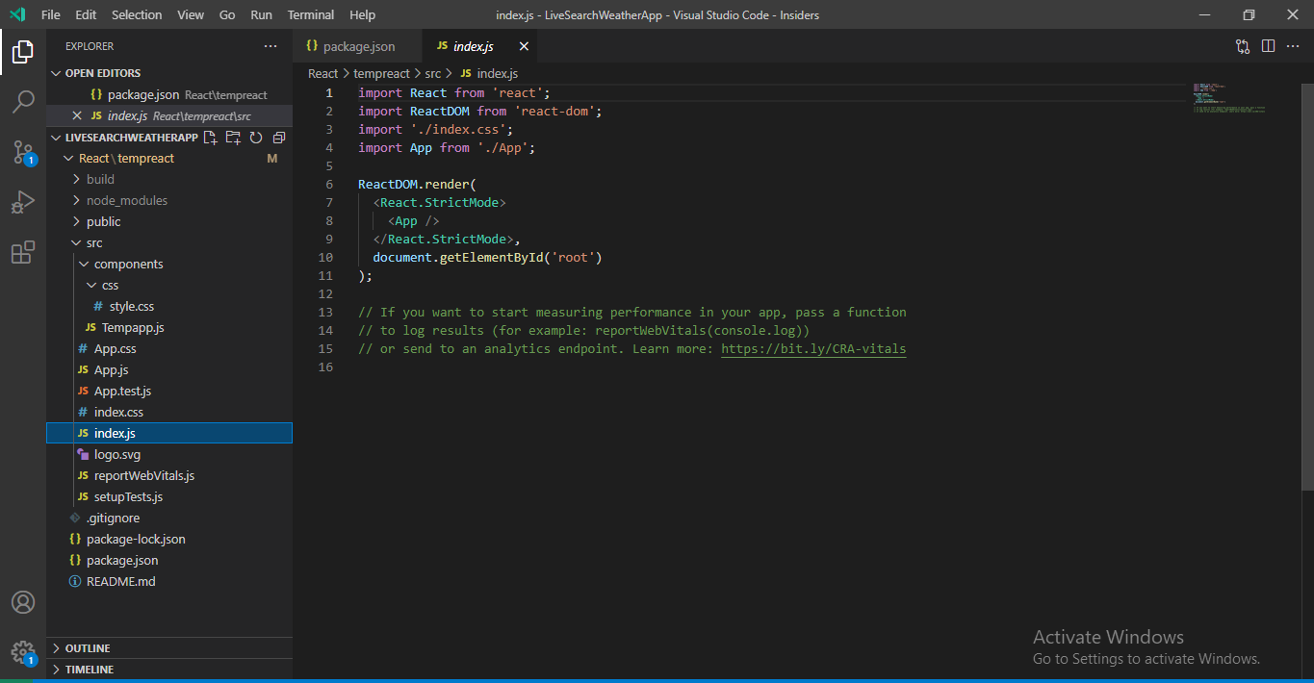

**In index.js file we import the app component and app component is called in index.js file.**

Department Of Computer Engineering & Applications 10

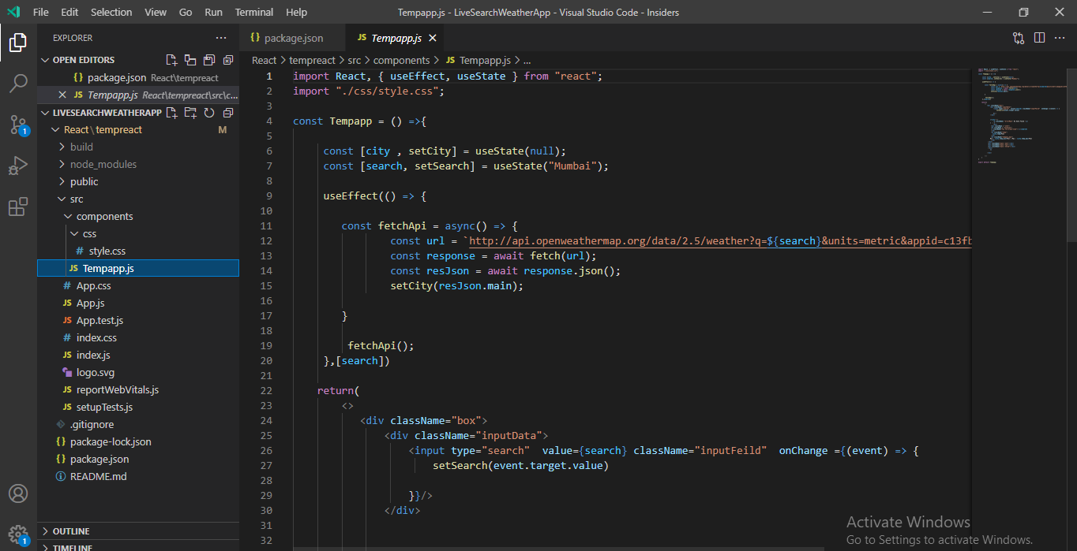

Department Of Computer Engineering & Applications 11

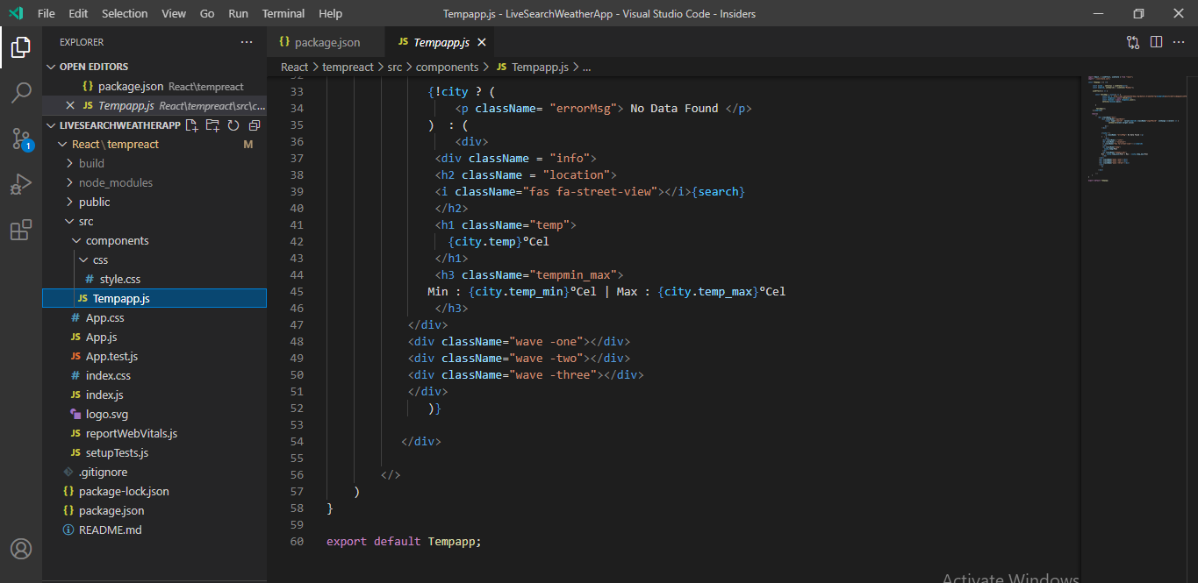

**In the Tempapp.js file we import the CSS file which stores the styling.**

Department Of Computer Engineering & Applications 12

**style.css file stores the styling of our application -:**

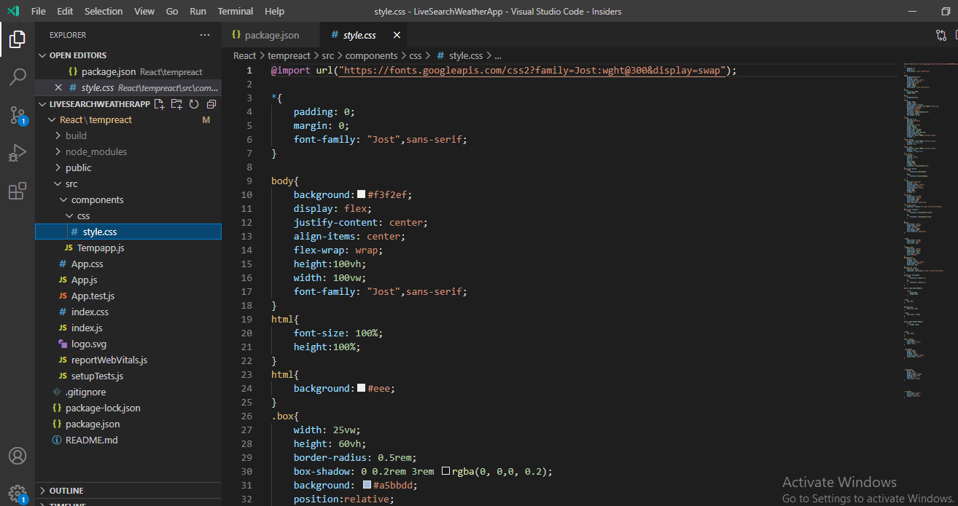

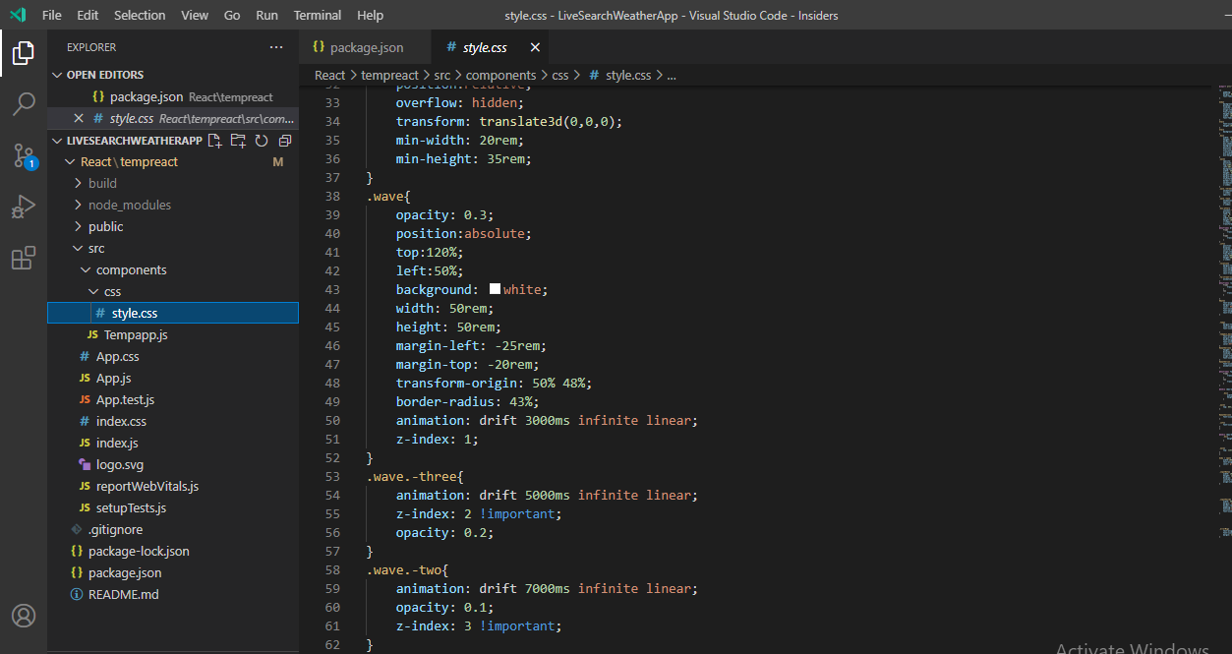

Department Of Computer Engineering & Applications 13

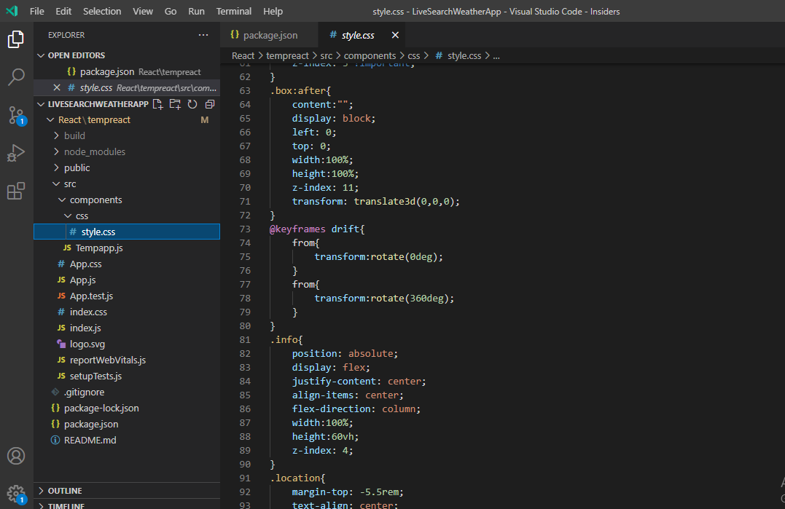

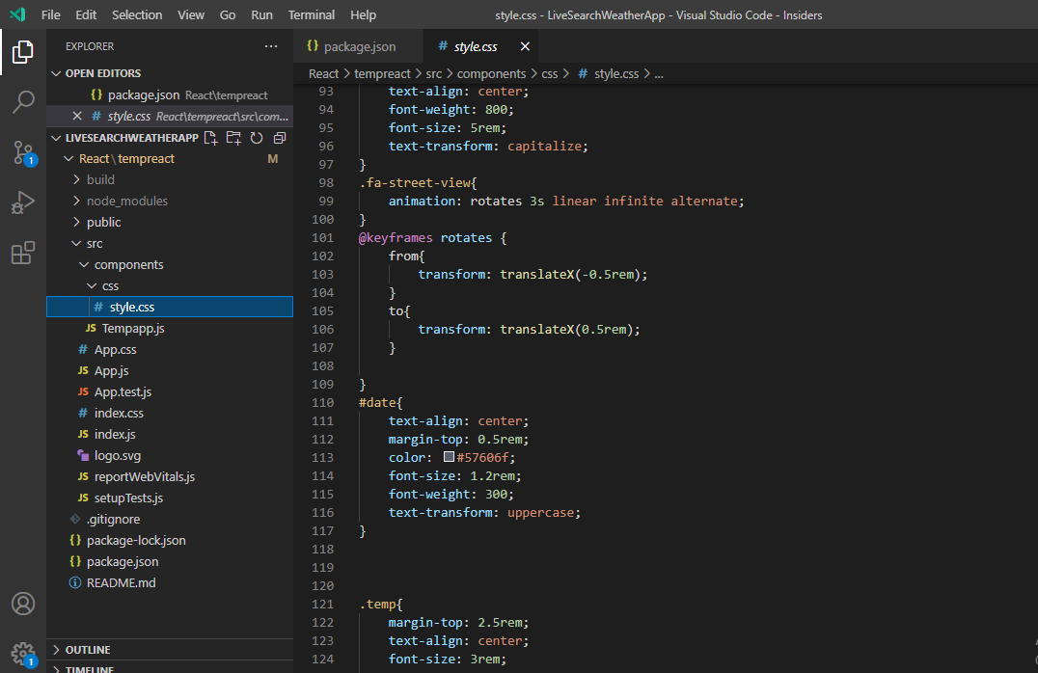

Department Of Computer Engineering & Applications 14

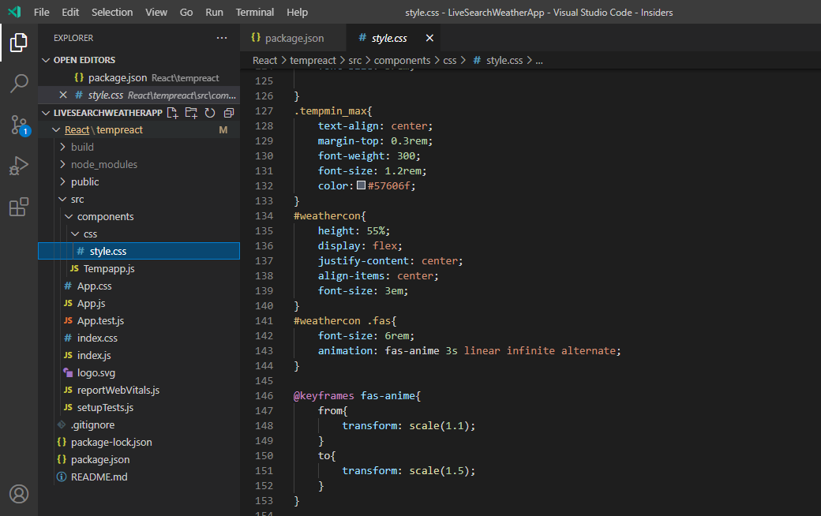

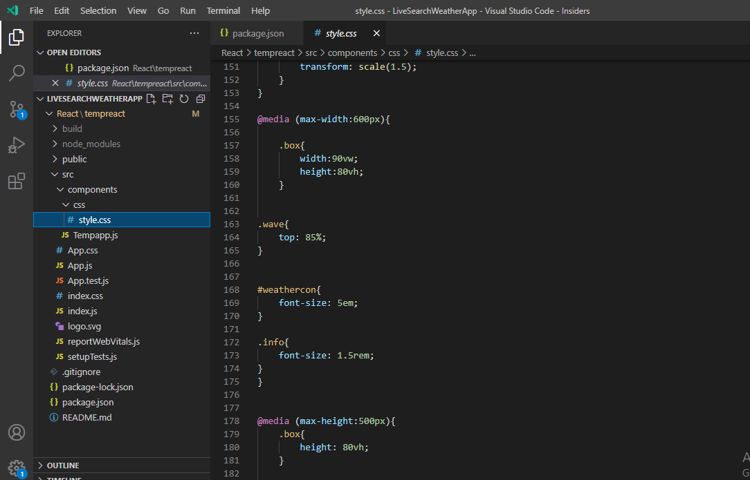

Department Of Computer Engineering & Applications 15

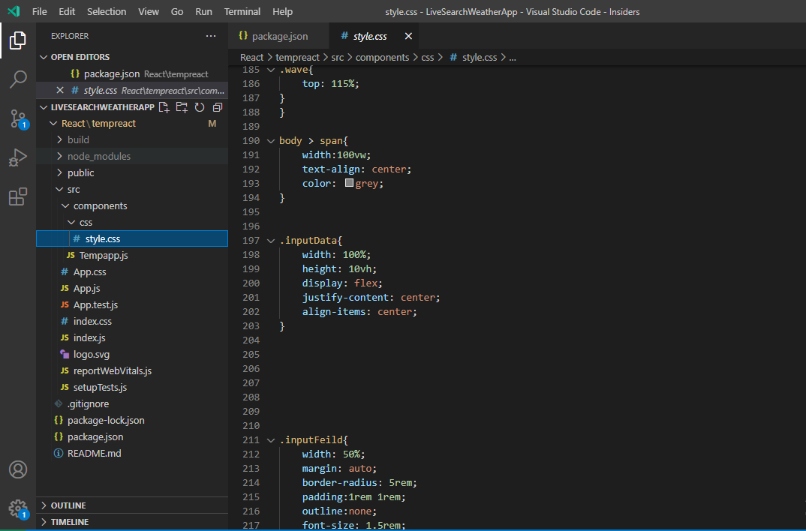

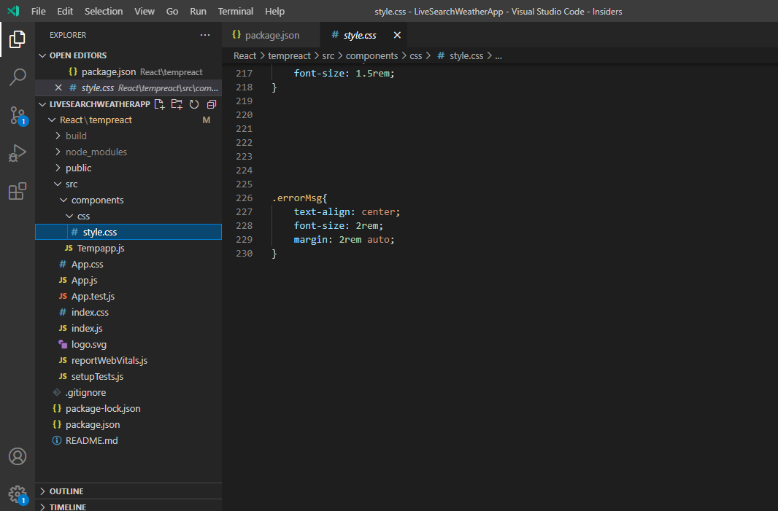

Department Of Computer Engineering & Applications 16

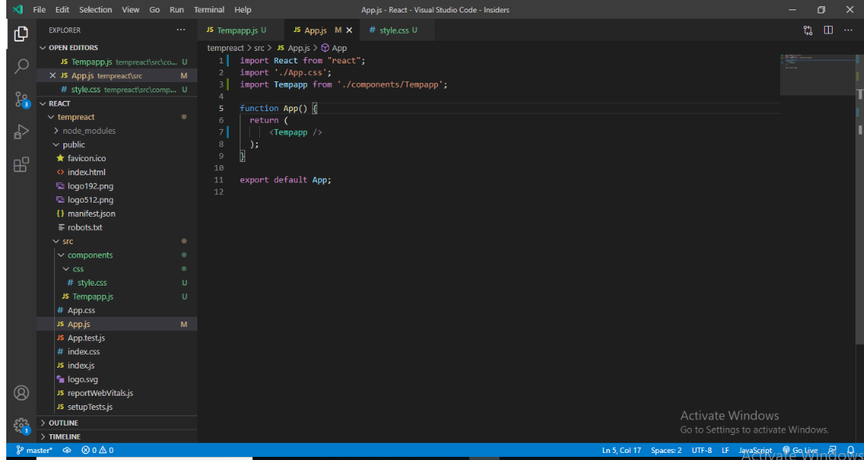

**In the app.js file we import the Tempapp component and call this component in the app.js file.**

Department Of Computer Engineering & Applications 17

**Conclusion**

In this section we summarize the experience gained by project team during development of “**Live Search Weather App”**.

We learned a lot through this project. This project has sharpened our concept of React JS like use of React Functional Component, React Hooks, React Fetch API, and many more concepts. This project not only tested our technical skills but also our temperament.

After the completion of project, user can search the weather conditions of different cities which they want to search.

* 1. **The Achievements**

1. Develop technical skills.

2. Growing creative thinking and imagination capability.

**7.2 Future Scope**

In the future, this project(Live Search Weather App) help users to make inform decisions.

Department Of Computer Engineering & Applications 18

**References**

<https://www.beta-labs.in/>

https://rapidapi.com/blog/weather-app-react/

Department Of Computer Engineering & Applications 19